**Code:**

#20CS007 Khush Bhalodiya

import img2pdf

from PIL import Image

# Importing the image file

imp_path = "C:/Users/khush/OneDrive/Desktop/Result.png"

# creating a pdf file.

pdf_path = "C:/Users/khush/OneDrive/Desktop/marksheet.pdf"

# creating a image file

image = Image.open(imp_path)

# creating a pdf from the image.

pdf_bytes = img2pdf.convert(image.filename)

# opening file

file = open(pdf_path, "wb")

# writing the file.

file.write(pdf_bytes)

# closing an image.

image.close()

# closing an file.

file.close()

print("Success!!")

**Output:**

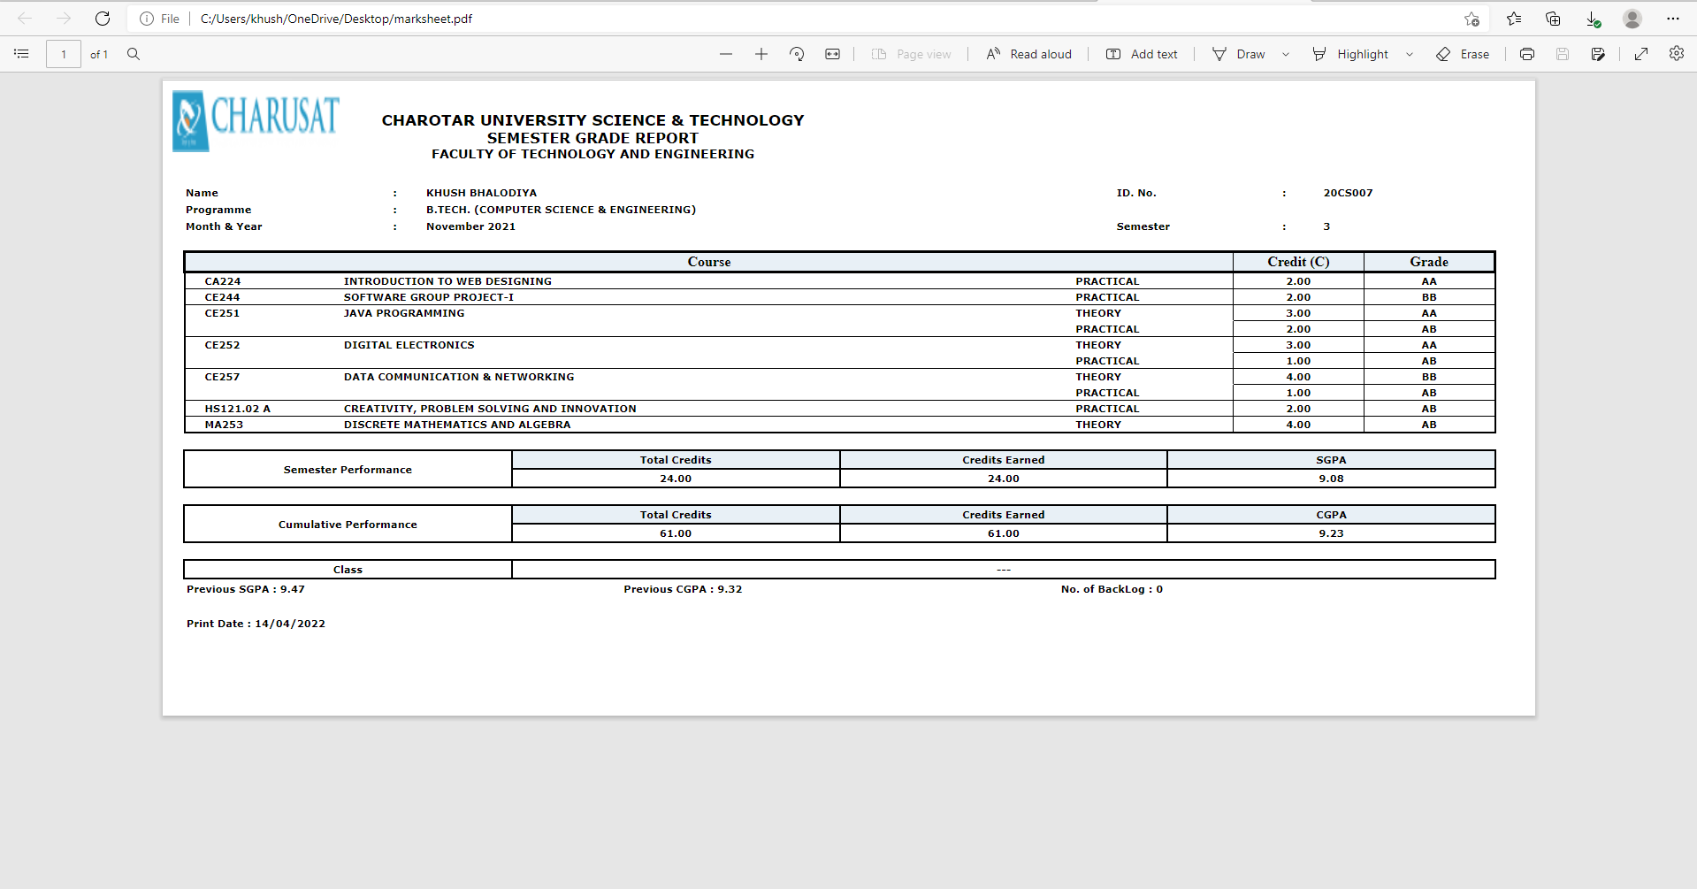

**GitHub Link:**

<https://github.com/Khush1351/Python-Practicals.git>